Experiment No 5.

Title: Implementation of Flow Control Mechanisms: A) Stop and wait ARQ B) Go back N C) Selective Repeat

Aim: To Develop C program for implementation of Flow Control Mechanisms A) Stop and wait ARQ B) Go back N C) Selective Repeat

Theory:

Flow Control Mechanism

A] Stop and Wait ARQ

**Characteristics**

* Used in Connection-oriented communication.
* It offers error and flows control
* It is used in Data Link and Transport Layers
* Stop and Wait for ARQ mainly implements the Sliding Window Protocol concept with Window Size 1

### Useful Terms:

* **Propagation Delay:**Amount of time taken by a packet to make a physical journey from one router to another router.

Propagation Delay = (Distance between routers) / (Velocity of propagation)

* RoundTripTime (**RTT**) = 2* Propagation Delay
* TimeOut (**TO**) =  2* RTT
* Time To Live (**TTL**) = 2* TimeOut. (Maximum TTL is 180 seconds)

### Simple Stop and Wait

#### Sender:

Rule 1) Send one data packet at a time.

Rule 2) Send the next packet only after receiving acknowledgement for the previous. 

#### Receiver:

Rule 1) Send acknowledgement after receiving and consuming a data packet.

Rule 2) After consuming packet acknowledgement need to be sent (Flow Control)

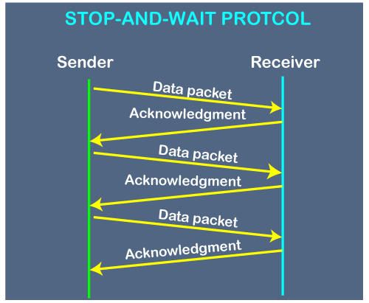

**Problems:**

1. **Lost Data**

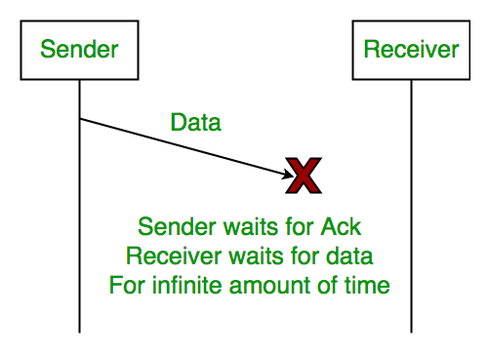

1. **Lost ACK**

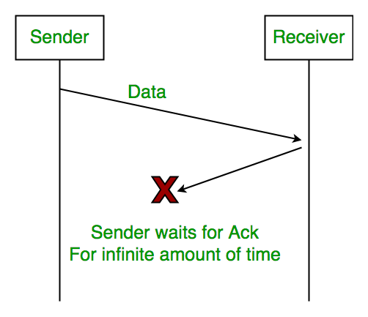

1. **Delayed acknowledgement or data**

After a timeout on the sender side, a long-delayed acknowledgement might be wrongly considered as acknowledgement of some other recent packet.

### Stop and Wait for ARQ (Automatic Repeat Request)

The above 3 problems are resolved by Stop and Wait for ARQ (Automatic Repeat Request) that does both error control and flow control.

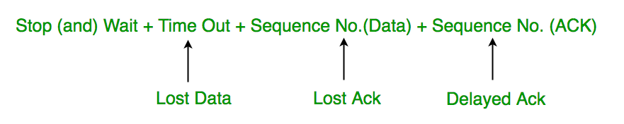

* 1. **Timeout**

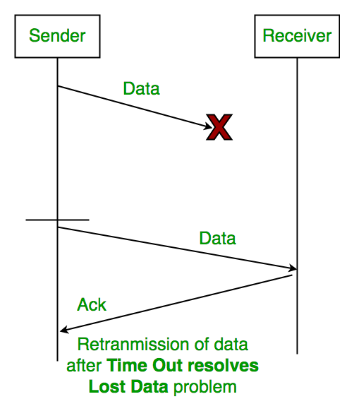

* 1. **Sequence Number(Data)**

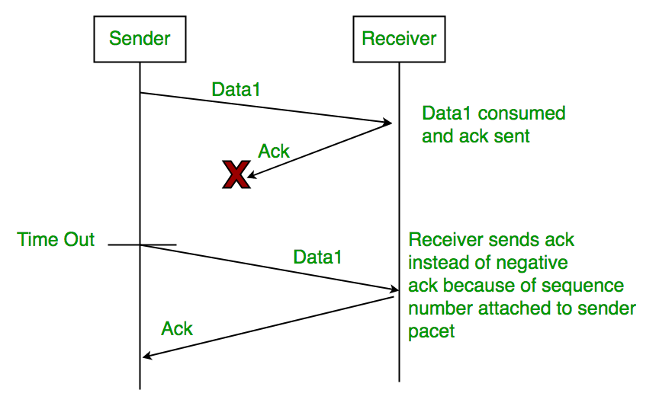

* 1. **Delayed Acknowledgement**

This is resolved by introducing sequence numbers for acknowledgement also.

### Working of Stop and Wait for ARQ:

1) Sender A sends a data frame or packet with sequence number 0.   
2) Receiver B, after receiving the data frame, sends an acknowledgement with sequence number 1 (the sequence number of the next expected data frame or packet)   
There is only a one-bit sequence number that implies that both sender and receiver have a buffer for one frame or packet only.

Before learning about the working of the stop and wait ARQ, we should be familiar with the window size of sender and receiver as the stop and wait ARQ is a type of sliding window protocol only.

In the stop and wait ARQ, both the sender and the receiver have windows of the same size. The window on the sender's side covers the sequence of data packets that are sent (or to be sent). On the other hand, the window on the receiver's side covers the sequence of data packets that are received (or to be received).

The size of the sender's window is 1. The window size of the receiver is the same as that of the sender i.e. 1. The sender's window size is represented using **Ws** and the receiver's window size is represented using **Wr**.

The overall working of the stop and wait ARQ is simple. Initially, the sender sends one frame as the window size is 1. The receiver on the other end receives the frame and sends the ACK for the correctly received frame. The sender waits for the ACK until the timer expires. If the sender does not receive the ACK within the timer limit, it re-transmits the frame for which the ACK has not been received.

Now, let us take an example to visualize the working of stop and wait ARQ or how the data frame is

transmitted using the stop and wait ARQ protocol. The image below shows the transmission of frames.

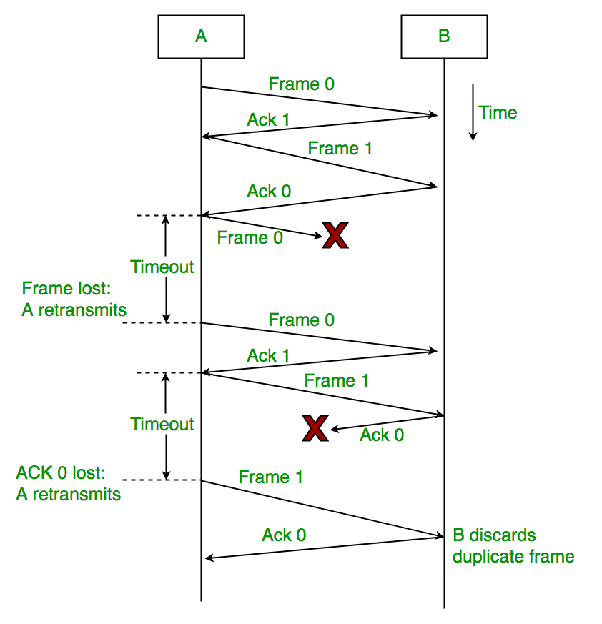

**Characteristics of Stop and Wait ARQ**

* The stop and wait ARD is a sliding window protocol with a window size equal to 1.
* The stop and wait ARQ is an example of the Closed Loop OR connection-oriented.
* The sender sends the data frame with a sequence number.
* The sender also maintains a copy of the data frame that is being currently sent so that if the ACK is not received then the sender can re-transmit the frame.
* The sender can send only one frame at a time and the receiver can also receive only one frame at a time.
* The stop and wait ARQ is a connection-oriented protocol.
* In the stop and wait ARQ, the sender needs to maintain a time tracker.